LAB Logbook

github: [ML finance github](https://github.com/markiplagat/MOD009701-coursework-2441743)

Lab 1

github-code Week 1 link-: [Week 1 link](https://github.com/markiplagat/MOD009701-coursework-2441743/blob/main/Week1_NumPy_ML_in_Finance_Final_.ipynb)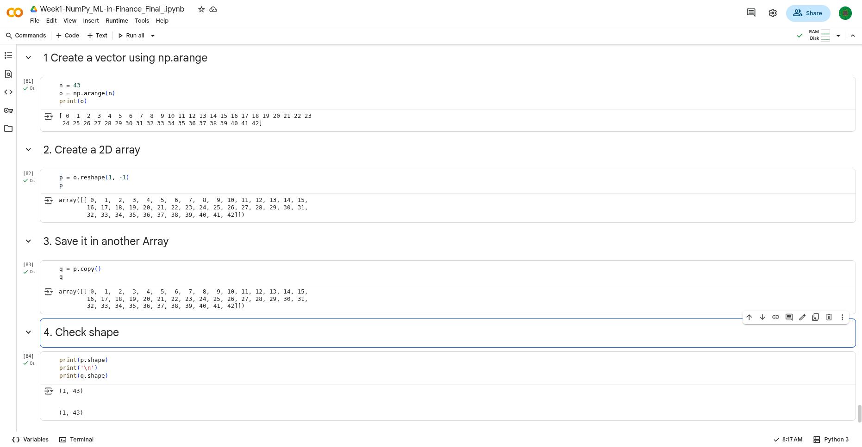

Colab: <https://colab.research.google.com/drive/1eoQyPnKTxEFt0b5BS6ZX4hlCZlRccpUr?usp=drive_link>

Lab 2

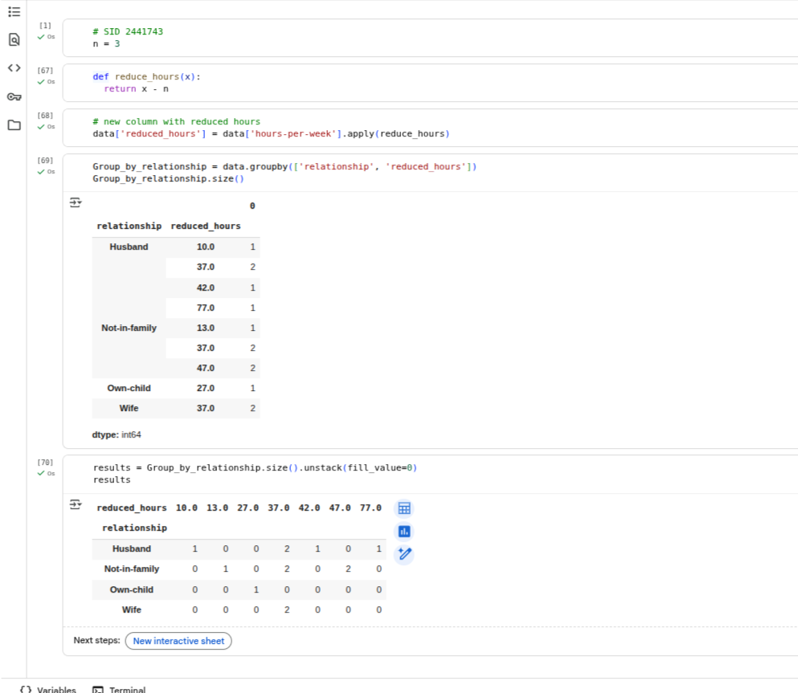

github: [github week2](https://github.com/markiplagat/MOD009701-coursework-2441743/blob/main/Week_2_Pandas_Introduction_ML_in_Finance_Proof_Colab.ipynb)

Lab 3

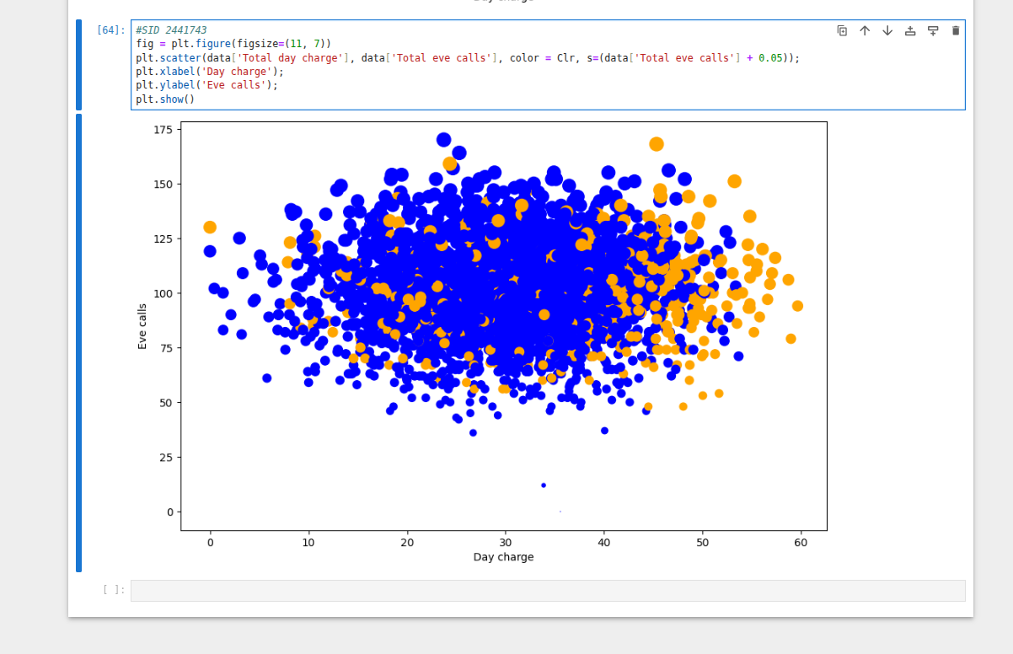

Lab 4

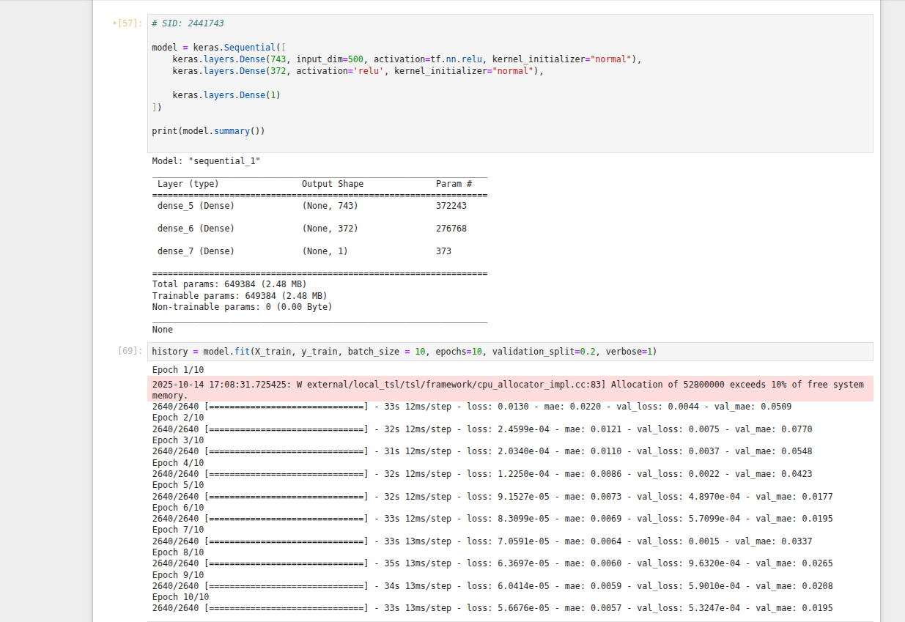

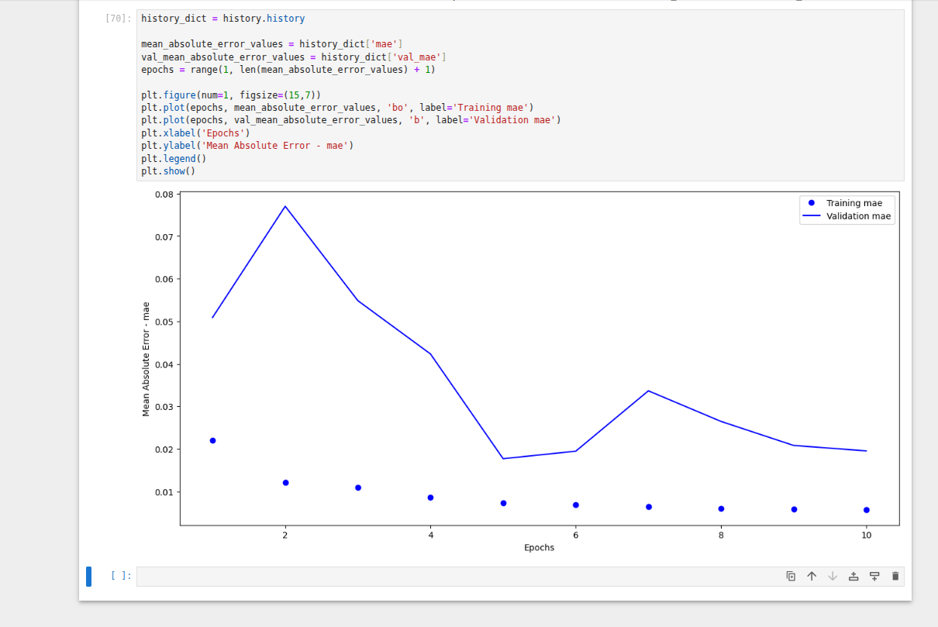

Lab 5

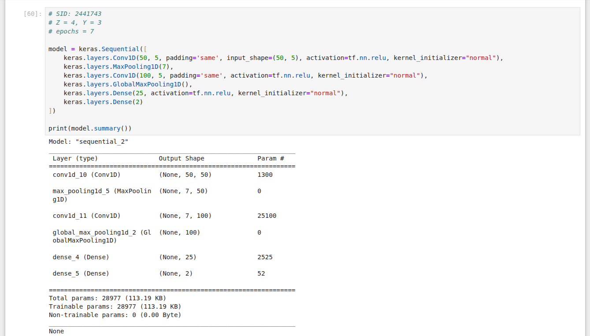

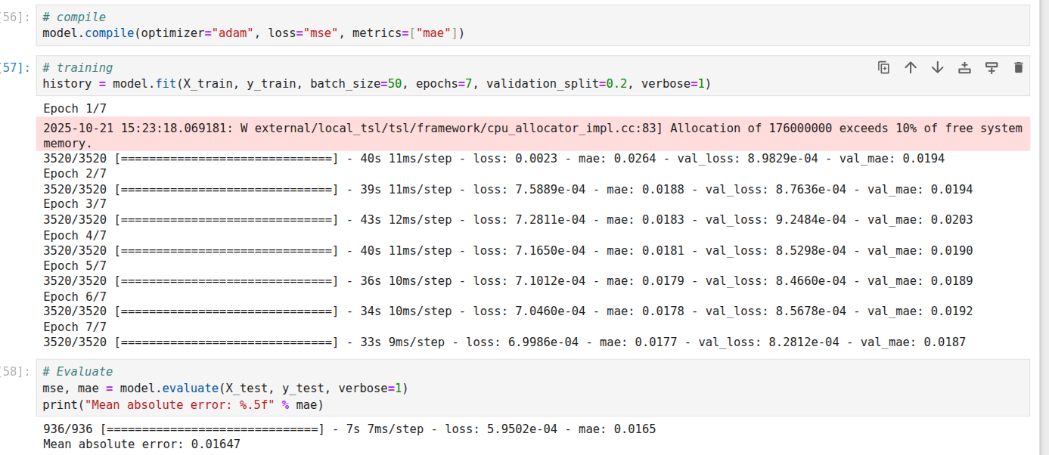

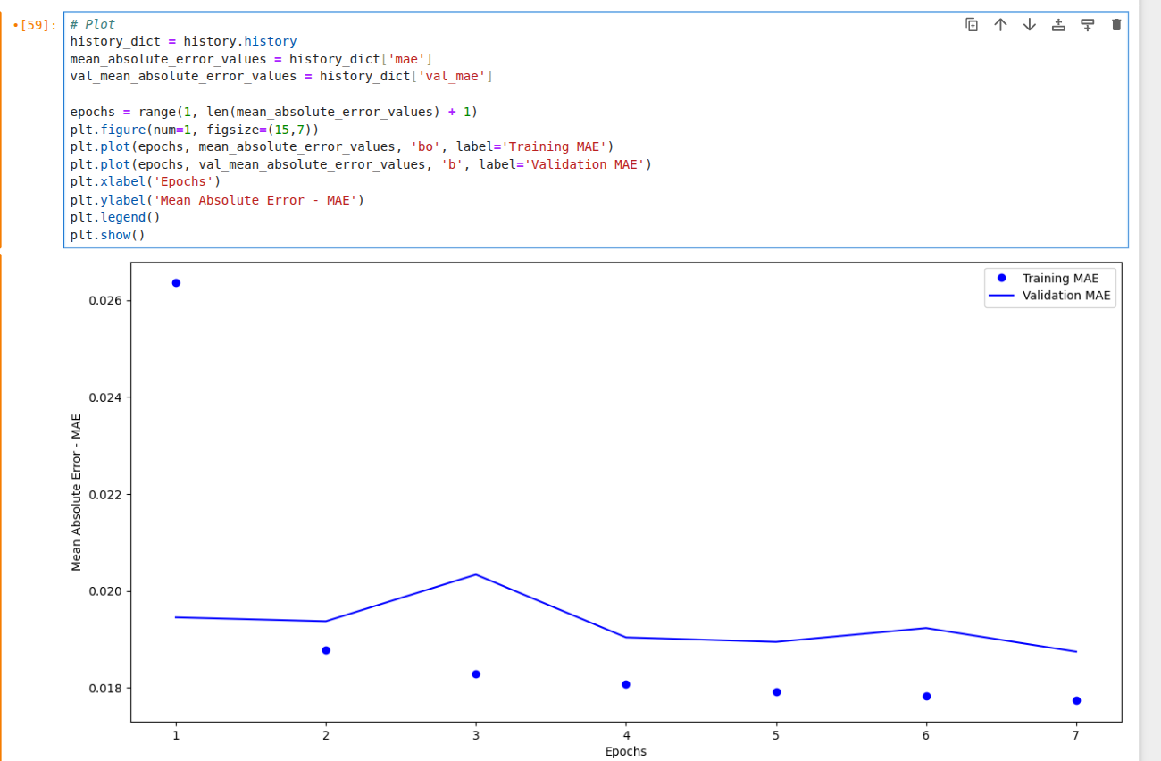

Lab 6

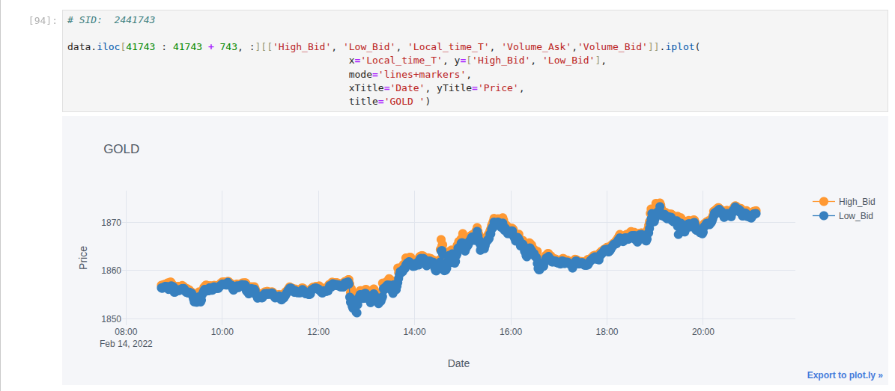

Lab 7

Lab 8

Lab 9

Lab 10

Lab 11

Lab 12